Wiskers R We
CATS
A cat is a black ball that throws its own litter box around when its having a temper tantrum.
Lets meet some of todays feline fiascos.
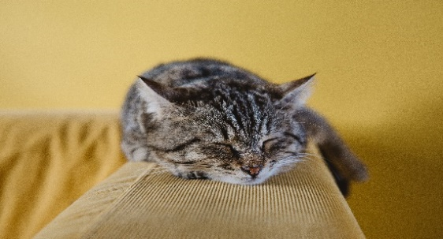
This is Luke Litterwalker
He’s a turtleshell. You can tell because he has a gray coat. That’s the sign for a Jedi being trained by Jedi master Yoda. He’s also never fond of his own parents.

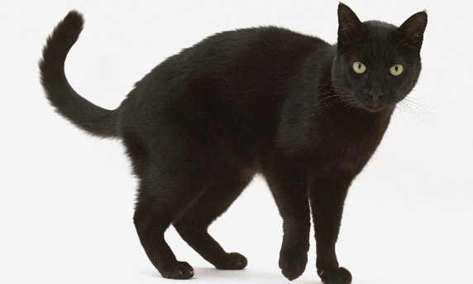
This here is Emperor Kittytien
He rules the Empire with his ultimate weapon, The Death Claw! But in his early days, he is elected for senator of the galaxy.
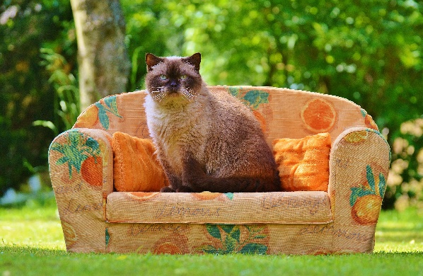
This may look look like a comfy cozy bed, but don’t be fooled. It’s Jabba the Kittys’ palace. He’s making it look like this because he wants to deceive people into going into his palace and eat them up.
Don’t wanna mess with him.

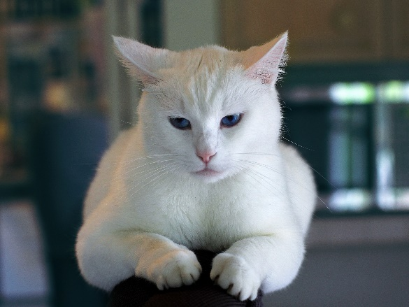

This is a Cattrooper. Cattroopers are the helpers of villains we’ll meet in future episodes.

That’s all for now, but there’ll be more to come.
Get a Star Wars themed cat for $10 or more!
HERE AT WISKERS R WE!!!!!!!!!!!!!!!!!!!!!!!!!!!!!!!!!!!!!!!!!!!!!!!!!!!!!!!!!!!!!!!!!!!!!!!!!!!!!!!!!!!!!!!!!!!!!

